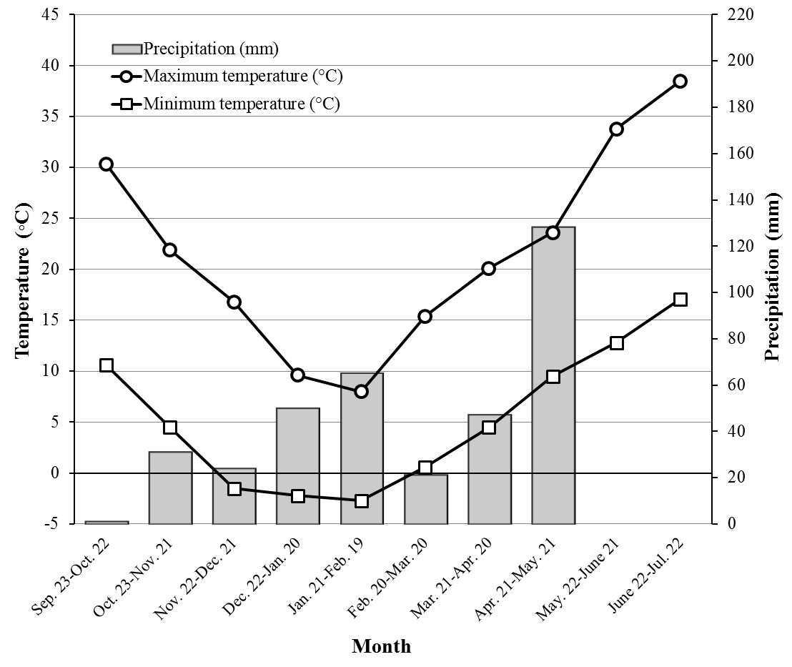
Figure S1. Minimum and maximum temperature as well as amount of precipitation during 2010-2011 cropping season of the experiment. Source: Meteorological Organization of Iran.

